Spring boot security.

With authentication and authorization with mysql db

Web starter,

Jpa starter

Mysql dependencies

Dev tools

Spring security

If view you want as thymeleaf then add it

Optional

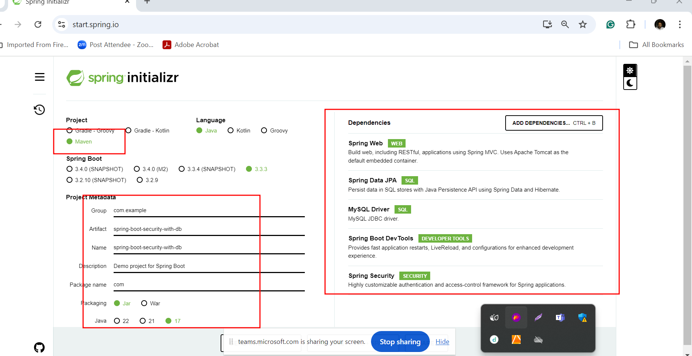

CSRF : Cross Site Request Forgery

We created account using post man client.

We can write the logic to check user and password. We get the message on post man client success or failure base upon the role.

<http://localhost:8080/admin>

<http://localhost:8080/user>

stateless and stateful

rest api is state less communication

JWT : JSON Web Token